**Model Risk Management with**

**IBM Watson OpenScale and**

**IBM OpenPages MRG**

**Beta User Guide**

Copyright © 2019 International Business Machine, Inc. All Rights Reserved.

This user guide is being provided exclusively to participants in a closed beta program for IBM Cloud – Watson OpenScale (the “Program”).

The Program is provided to you under the terms of the letter agreement you or your company representative signed and the International License Agreement for Early Release of Programs and accompanying License Information IBM Cloud – Watson OpenScale, (the “Agreement”). The terms of the Agreement shall prevail over the terms of any click-through licenses that accompany the Program. The evaluation period begins on the date that Licensee agrees to the terms of this Agreement and ends after 60 days. The Program is being provided to you for evaluation of limited functionality. There is no migration supported from the beta to any other level of the Program. THE SOFTWARE AND DOCUMENTATION IS PROVIDED “AS IS” WITHOUT ANY EXPRESS OR IMPLIED WARRANTY OF ANY KIND.

Model Risk Management with IBM Watson OpenScale and IBM OpenPages MRG

WELCOME to the Model Risk Management closed beta for IBM Watson OpenScale and IBM OpenPages Model Risk Governance (MRG). In addition to giving some background information about models, model risk, and how to manage it, this guide takes you through the steps of creating pre-production and production models.

Financial institutions manage many complex and integrated areas of risk. Management of model risk is critical to meet regulatory requirements and to protect institutions from operational and reputational risk. It is precisely this scenario that the closed beta is meant to demonstrate.

# What is a Model?

The Federal Reserve and Office of the Comptroller of the Currency guidance SR Letter 11-7 defines a Model as “…a quantitative method, system, or approach that applies statistical, economic, financial, or mathematical theories, techniques, and assumptions to process input data into quantitative estimates.”

These types of models, either deterministic or probabilistic, raise different model risk management challenges.

## What is Model Risk?

Model risk is a type of risk that occurs when a mathematical model is used in financial institutions to predict and measure quantitative information, and the model performs inadequately. This can lead to adverse outcomes for the firm and operational losses in millions.

## Model Development Cycle

There are many challenges with machine learning and deep learning models. For example, you need to face the lack of knowledge of methods used by Model Developers / Vendors along with inconsistent documentation and increased volume of model change.

Tests to be run on machine learning and deep learning models differ from straightforward application testing:

* Drift: Any change in input data also known as Drift can cause the model to make inaccurate decisions, impacting business KPIs
* Bias: Training data may be cleaned to be free from bias but runtime data may induce biased behavior of model
* Explainability: Traditional statistical models are simpler to interpret and explain
* Missing Validation/Test Data: Model training data sets may not capture the range of data or combinations that could be encountered in runtime

Validation and monitoring of AI models is necessary in addition to govern and manage risk.

# Watson OpenScale & IBM OpenPages MRG Integration

IBM offers an end-to-end model risk management solution for financial services with IBM Watson OpenScale and IBM OpenPages with Watson. IBM OpenPages MRG offers model risk governance that enables you to store and manage a comprehensive model inventory. IBM Watson OpenScale monitors and measures outcomes from AI Models across its lifecycle and performs model validations. What is IBM OpenPages Model Risk Governance (MRG)? For more information, see the [IBM OpenPages with Watson product page](https://www.ibm.com/us-en/marketplace/governance-risk-and-compliance) and the [IBM OpenPages online help](https://www.ibm.com/support/knowledgecenter/SSFUEU_8.0.0/op_grc_user/c_oppm_mrg_intr_module_description.html).

# Set up your beta environment

Let’s get started! Before you begin using the model risk management features, you’ll need to set up the following services on IBM Cloud:

* Watson OpenScale, which provides MRM features and metrics
* Watson Machine Learning (2 separate instances, one for pre-prod and one for prod), which provides the engine for creating predictive models. This tutorial shows how to use Watson Machine Learning as model serving engine, but you can also use any other supported ML engine)
* Watson Studio, which provides the ability to run notebooks and secure assets. (This tutorial shows how to use Watson Studio to create the provided sample models, but you can also use any other IDE to build models)
* [Optional] Cloud Object Storage, which gives you a place to store model assets, such as training data. For the tutorial, you’ll use an internal database, however, you might want to set up Cloud Object Storage for your own work.

For your instance of IBM OpenPages, you are provided a single log in to use on an already provisioned system. It is here that you will manage models and view the metrics that are generated by Watson OpenScale. As part of the closed beta, you will receive login information in an email from IBM. Write the information that you need to connect to IBM OpenPages in the spaces provided:

|  |  |
| --- | --- |
| URL | <https://softlayer-dev1.op-ibm.com> |
| Username  (check email sent by IBM) |  |
| Password  (check email sent by IBM) |  |

## Required file

In addition to the previously mentioned services, you must also have the following sample file:

* IBM_CloudOP_MRM.ipynb

The file can be downloaded from the following GitHub repository: <https://github.com/pmservice/ai-openscale-tutorials/blob/master/beta_features/mrm/notebooks/IBM_CloudOP_MRM.ipynb>

# Create an IBMid and IBM Cloud account

In case you don't have an IBM Cloud account yet, you’ll need to start by creating one.

1. Point your web browser to the following URL: <https://cloud.ibm.com/registration>
2. Follow instructions to create an IBMid and IBM Cloud Account.

## Add services to your IBM Cloud account

As soon as you have an IBM Cloud account, you can use the dashboard to add the required service~~s~~. For each service, you can choose the Lite or Free plan. You must have instances for the following services: Watson OpenScale, Watson Studio, and Watson Machine Learning (2 Instances).

1. From the Navigation Menu (  /var/folders/pp/fktrqfzs0cn8pz3n6hv9mxbw0000gn/T/com.microsoft.Word/Content.MSO/78F6FF08.tmp ), click **Resource list**.
2. Click the **Create resource** button.
3. Search for each of the required services by entering keywords, such as openscale, studio, or machine learning.

**Note**: You might not be able to add two Lite plan instances of Watson Machine Learning to your account. Either create the second instance using the Watson Machine Learning Standard plan or create a second IBM Cloud Account that is linked to a separate email address to create the second Watson Machine Machine Learning instance (Link to register the second account: <https://cloud.ibm.com/registration>).

## Add a Cloud Object Storage instance

Use Cloud Object Storage to store training data. After you create an instance Cloud Object Storage, Watson Studio, Watson Machine Learning, and Watson OpenScale will be able to access the buckets that are created as part of the model creation process.

1. Use your primary IBMid to log into your IBM Cloud account.
2. From the IBM Cloud Dashboard, click the Add resource button, then click Storage.
3. Click the Object Storage tile, select the Lite plan, then click the Create button.

# /var/folders/pp/fktrqfzs0cn8pz3n6hv9mxbw0000gn/T/com.microsoft.Word/Content.MSO/FD6978D4.tmp Work in Watson Studio

In IBM Watson Studio, you will create a project and run a notebook to perform most of the set-up tasks, including the following steps:

* create 2 machine models
* connect Watson OpenScale to IBM OpenPages
* create model deployments and configure monitors in Watson OpenScale

## Step 1: Create the pre-prod project in Watson Studio

When you first start Watson Studio (hint: use the IBM Cloud dashboard, find your instance of Watson Studio and click the **Get Started** button) you have the option of taking a tour. Your first task is to create a project to which you associate the Watson Machine Learning instance that you created for your pre-production work.

1. Click the **Create a project** tile.
2. Click the **Create an empty project** tile.
3. Give the project a name and description: In the **Name** field, type **MRM – Pre-prod**. You’ll use this project for all your pre-production models.
4. You’ll notice that an instance of Cloud Object Storage is required. Go ahead and create an instance of that on IBM Cloud if you haven’t already.
5. Click the **Create** button.

## Step 2: Associate your new project with the Watson Machine Learning instance

Now you need to associate your pre-prod instance of Watson Machine Learning to your project. You’ll do this by adding it as an associated service.

1. From the **MRM – Pre-prod** project screen, click the **Settings** tab.
2. In the **Associated services** pane, click the **Add service** button, and then click **Watson**.
3. Find the **Watson Machine Learning** tile and click **Add**.
4. From the **Machine Learning** configuration window, click the **Existing** tab.
5. From the **Existing Service Instance** drop-down box, select the Machine Learning-Pre-Prod instance and click the **Select** button.

## Step 3: Add the sample beta notebook to the project

As part of your closed beta information package, you were given access to a Watson Studio notebook. You’ll use it to set up your connection between Watson OpenScale and IBM OpenPages, to create and deploy pre-prod models, and configure the model deployments in Watson OpenScale.

1. From the project page, click the **Add to project** button.
2. Click the **Notebook** tile.
3. Click the **From URL** tab and then type or copy the following URL: https://github.com/pmservice/ai-openscale-tutorials/blob/master/beta_features/mrm/notebooks/IBM_CloudOP_MRM.ipynb
4. Add a name and description and click the **Create notebook** button.

## Step 4: Run the sample beta notebook

The newly created notebook is opened in Watson Studio in the integrated notebook editor. You need to update some of the credentials and then run the notebook to create your pre-prod model.

1. In the corresponding code box, paste your IBM Cloud API:
   1. From the IBM Cloud toolbar, click your Account name, such as <Your user name>’s Account.
   2. From the Manage menu, click **Access (IAM)**.
   3. In the navigation bar, click IBM Cloud API keys.
   4. Click the Create an IBM Cloud API key button.
   5. Type a name and description and then click Save.
   6. Copy the newly created API key and paste it into your notebook in the CLOUD_API_KEY code box, which is the first code box.
2. In the corresponding code boxes, paste your credentials from the pre-prod and prod instances of Watson Machine Learning:
   1. Go to the IBM Cloud dashboard.
   2. In the Resource summary section, click Services.
   3. Click Machine Learning-Pre-Prod.
   4. In the navigation pane, click Service credentials.
   5. Click the New credential button.
   6. Copy your credentials by clicking the copy icon.
   7. Return to the notebook editor and update the credentials by replacing the sample credentials with your own in the second code box.
   8. Repeat the preceding steps for the prod instance in the third code box.
3. To restart the notebook and clear the output, from the **Kernel** menu, click **Restart & Clear Output**.
4. Run the notebook one cell at a time by using the Run option. Ensure that a cell completes before running the next cell. Be sure to read directions for steps that must be taken during the intervening cells. For example, at one point, you are directed to move your model into production before continuing running the notebook.

Congratulations! You have used a notebook to create a pre-prod model. You can check inside Watson Studio, where you will now see the model listed as one of the assets. You have also already deployed this model, which means that you can go to IBM Watson OpenScale to add the model there.

# /var/folders/pp/fktrqfzs0cn8pz3n6hv9mxbw0000gn/T/com.microsoft.Word/Content.MSO/AC865A02.tmp Work in IBM Watson OpenScale

You’ll use IBM Watson OpenScale to validate and monitor your models and to process metrics. First, you need to do some set up.

## Step 1: Activate model risk management features

As part of the closed beta cohort, you can activate the model risk management beta features on IBM Watson OpenScale. The following sections detail how to activate the beta features on the IBM Cloud and the IBM Cloud Pak for Data environments:

## On IBM Cloud

To work with IBM Watson OpenScale, you must already have an IBM Cloud instance and you must have provisioned an IBM Watson OpenScale instance.

1. Launch Watson OpenScale.
   1. From the IBM Cloud Dashboard, click Services.
   2. Click **Watson OpenScale**
   3. Click the **Launch Application** button.
2. When prompted about running automatic setup, click the **No thanks** button.
3. From the **Insights** dashboard, add the following to the URL: **?mrm=true**

After you append the variable, the URL should look like the following sample: <https://aiopenscale.cloud.ibm.com/aiopenscale/insights?mrm=true>

## Step 2: Perform analysis in Watson OpenScale

After you run the set-up notebook and activate the MRM beta features, you can both see and compare the sample evaluations in Watson OpenScale. There is a downloadable report, the Model Summary Report, that includes all the quality measures, fairness measures, and drift magnitude.

1. From the **Insights** dashboard, click the model deployment tile
2. From the **Actions** drop-down box, click one of the following analysis options:
   1. **Past evaluations**: Lists all the previous versions of the evaluation.
   2. **Compare**: Compare any of the models, but especially versions of the same model, for best performance.
   3. **Download report PDF**: Generates the model summary report, which gives you all of the metrics and the explanation for why they were scored the way they were.
   4. **Send to OpenPages now**: Sends all the metrics to the OpenPages model record that you associated to the OpenScale model deployment. In OpenPages, the metrics are listed in the graphical flow diagram and are clickable so that you can drill down into each metric.

# Review results in IBM OpenPages



After you send all the metrics to IBM OpenPages, you are able to review the metrics in OpenPages as part of the Pre-Implementation Review. HINT: You can use the notebook to go directly to the model in OpenPages. Go to the **Create an OpenPages Model** section (code cell 12) and find the Model Name = <model name> and OpenPages Model Id = <model ID> output. Use them to search for your model in OpenPages.

1. Find the model in IBM OpenPages by using the model name, such as MOD_0000206.
2. Review the metrics from Watson OpenScale by expanding the OpenScale Metrics twisty:  
   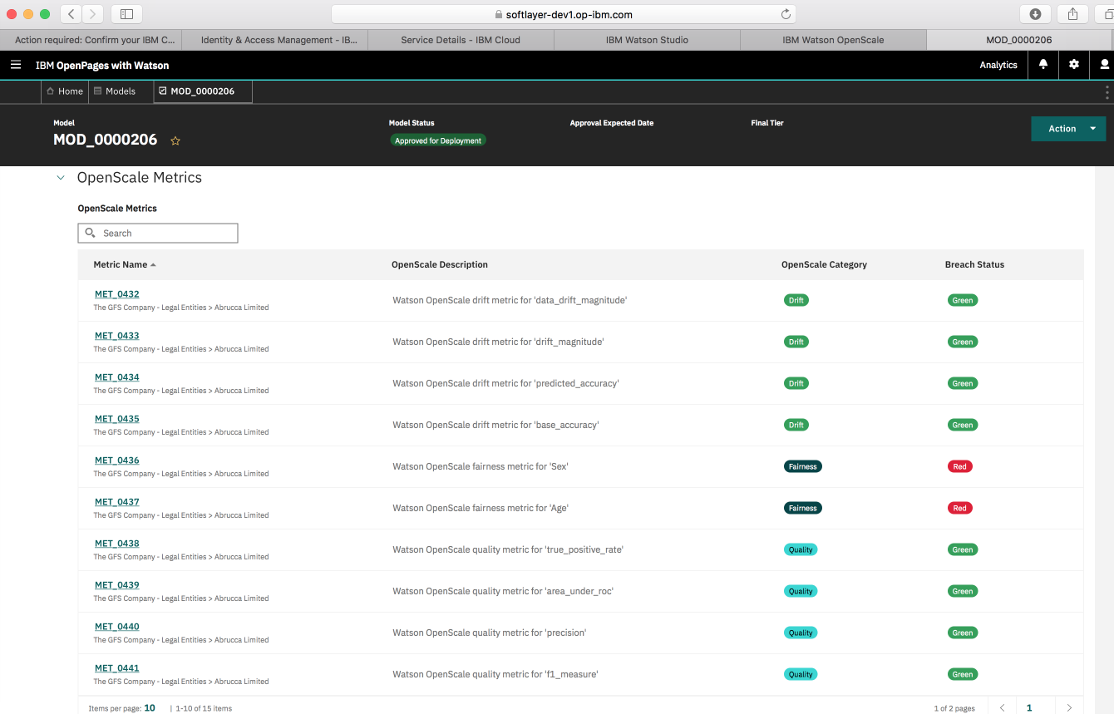
3. In addition to a list of metrics, you can view metrics by type in a graphical format by expanding the OpenScale Metrics Summary twisty:  
     
   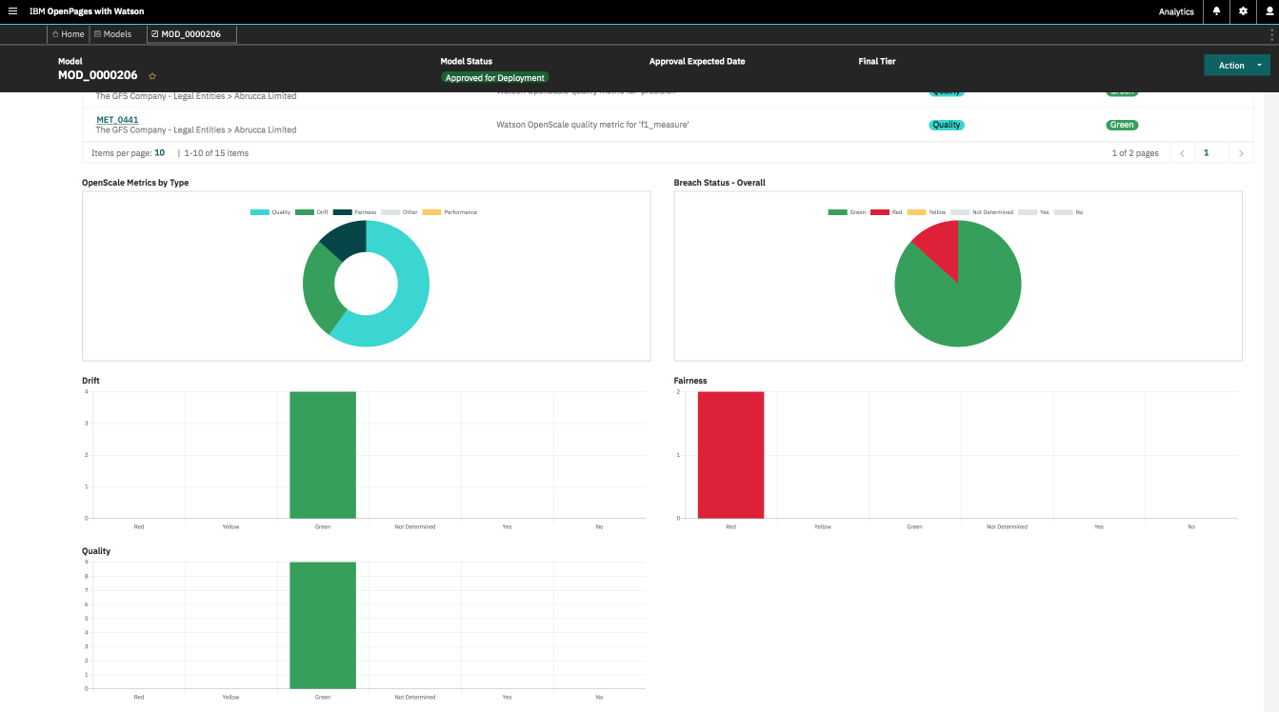
4. The Associations view provides relationships in the form of a tree:  
     
   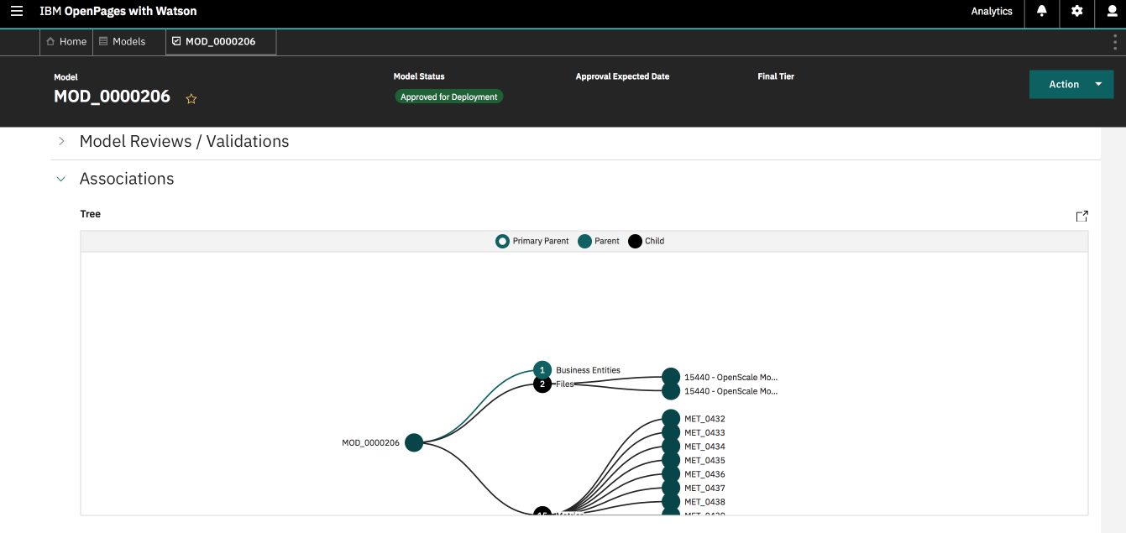
5. The **Supporting files and artifacts** pane gives you access to all the Watson OpenScale model risk management reports that are run:   
     
   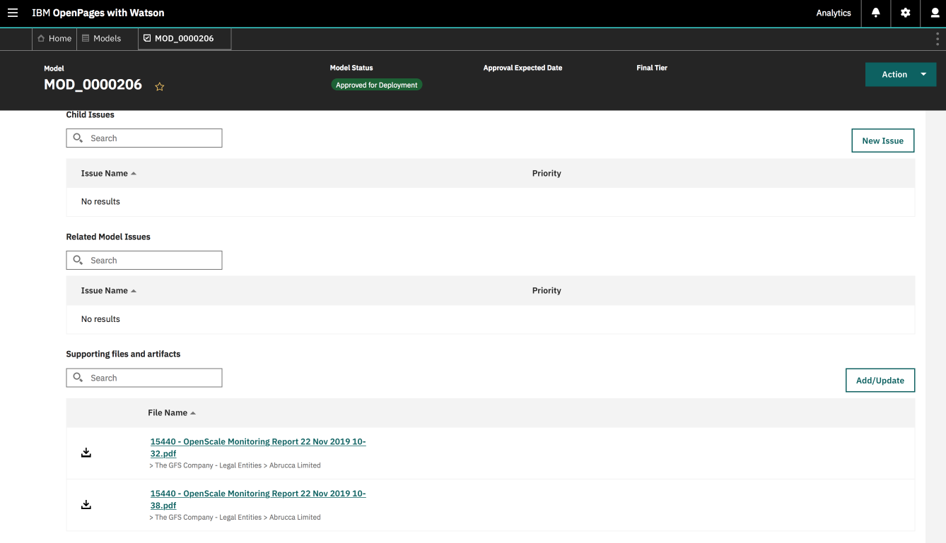

# Change the model status in IBM OpenPages

As part of the overall model risk governance workflow, the models you create are typically worked on by several different personas or job roles. For example, there might be a data scientist who is the model owner, a model validator, and model reviewer. For the purposes of the beta, you will act in all of these roles to see how the model can progress from one status to the next.

To do this, you must open the model and use the Actions drop-down  box to set the model status. Use the ID, such as OpenPagesAdministrator that was given to you to be the model owner, validator, and final approver. For the next part of the tutorial, you’ll want the status to be Approved for Deployment.

1. In IBM OpenPages, locate the model you want to promote.
2. From the Actions drop-down  box, click Approved.   
   If for some reason, you don’t see the Approved option, you might need to move the model through other steps, such as **Submit for Pre Implementation Review** or **Submit for Approval**.

# Deploy a new model to production in Watson OpenScale

Push the best model to production. Create a production record by importing from a pre-production model. After the model is approved for deployment in IBM OpenPages, you can send the model to production in Watson OpenScale.

1. Review the status of the model deployment:  
     
   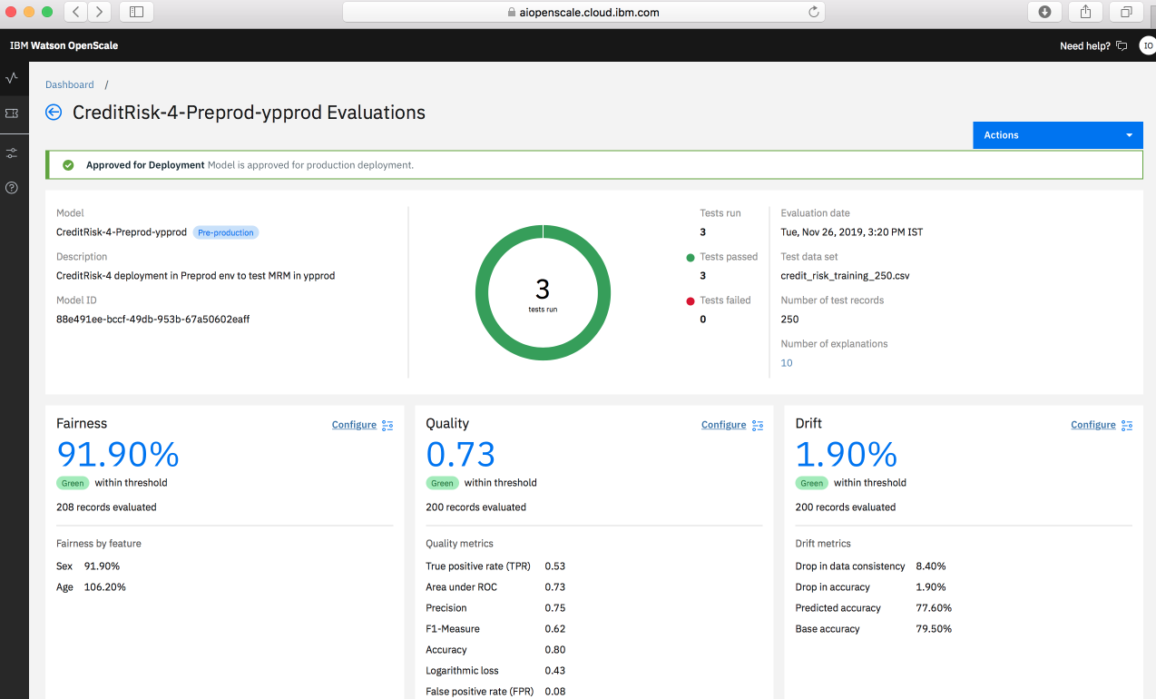
2. Return to the **sample beta notebook** and run the cells to send the model to production.
3. You can now view the production model deployment tile. In a regular production environment, it initially appears empty until enough data is gathered and time has passed for metric calculation to be triggered. For the beta, the notebook adds data and runs the monitors so that you can see the results right away.  
     
   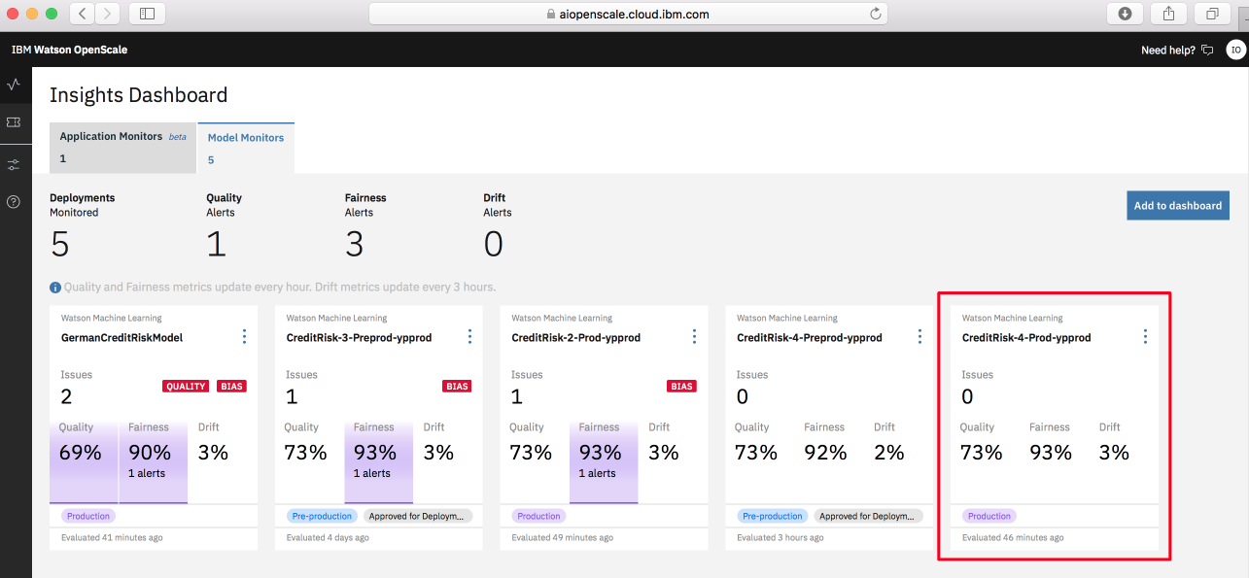

# Use the analysis of fairness to redefine the model, possibly by using a different algorithm.

Watson OpenScale enables you to compare models by looking at the key metrics in a side-by-side comparison. Use this feature to determine which version of a model is the best one to send to production or which model might need work:  
  
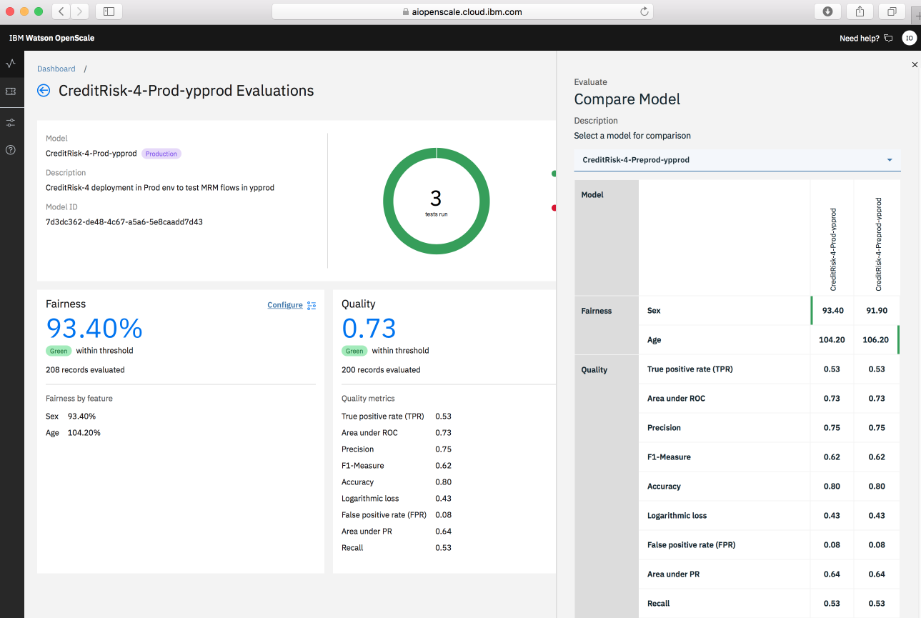

Because of the connection to Watson OpenScale, you can get alerts in IBM OpenPages for items that require attention or missing pieces of information:   
  
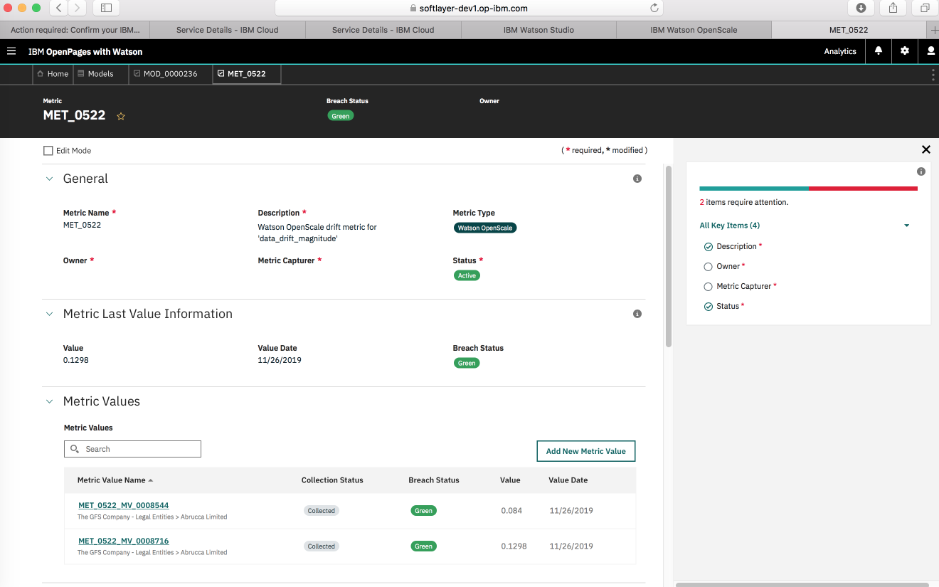

You can set up a regular schedule for sending metrics to IBM OpenPages:

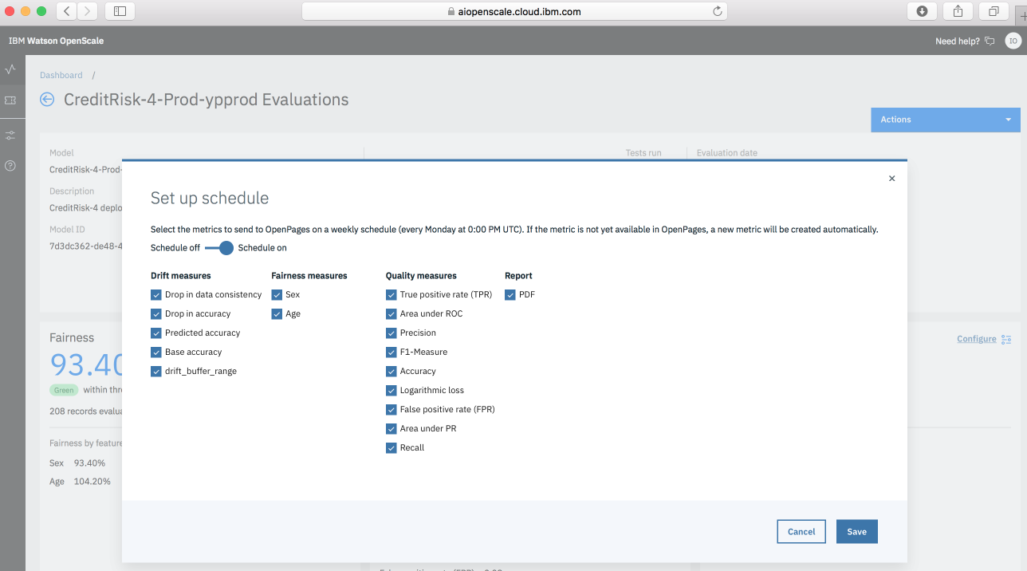

# Known issues and limitations for beta

Because this is a closed beta, you are working in a non-standard and non-production environment. It is expected that there will be some limitations, issues, and non-standard ways of working. At the start of the closed beta, the offering management team is aware of the following issues:

## You cannot create a second free instance of Watson Machine Learning on IBM Cloud

Although you are welcome to use lite plans or free instances of the IBM Cloud services, it is impossible to create two free instances of Watson Machine Learning. Without a paid account you cannot create the second instance in the same IBM Cloud account. As a workaround, you can create a second IBMid and a second IBM Cloud instance so that you can then create a second free Watson Machine Learning instance. You must ensure that one is designated as your pre-production and the other as your production system consistently within Watson Studio and Watson OpenScale.

## Payload logging requires additional submissions for Amazon Web Services binary, Microsoft Azure binary and multiclass, and Native XGBoost binary problem types

If you build your own notebook to try out model risk management features for any of the models that use certain frameworks, you must send the same record for initial scoring a second time. This is needed for the initial setup of payload logging when you configure monitors. The following frameworks and problem types are affected:

* Amazon Web Services binary
* Microsoft Azure binary and multiclass
* Native XGBoost binary

## Common log per client for IBM OpenPages

Because each client in the closed beta is assigned a single user ID for IBM OpenPages, there will be a single common log that is available to every participant in the closed beta. Clients are responsible for ensuring that no proprietary or personally identifiable information is recorded in the IBM OpenPages log.